Stack Theory Questions:
IV. Given a stack, three push functions push(1), push(2), push(3) are being called.
However, in between these push() functions or at the end of calling these push() functions, three pop() functions are being called.
Which sequence of outputs can never be generated given this scenario? [1 mark]
(a) 3 2 1 (b) 3 1 2 (c) 2 1 3 (d) 1 2 3
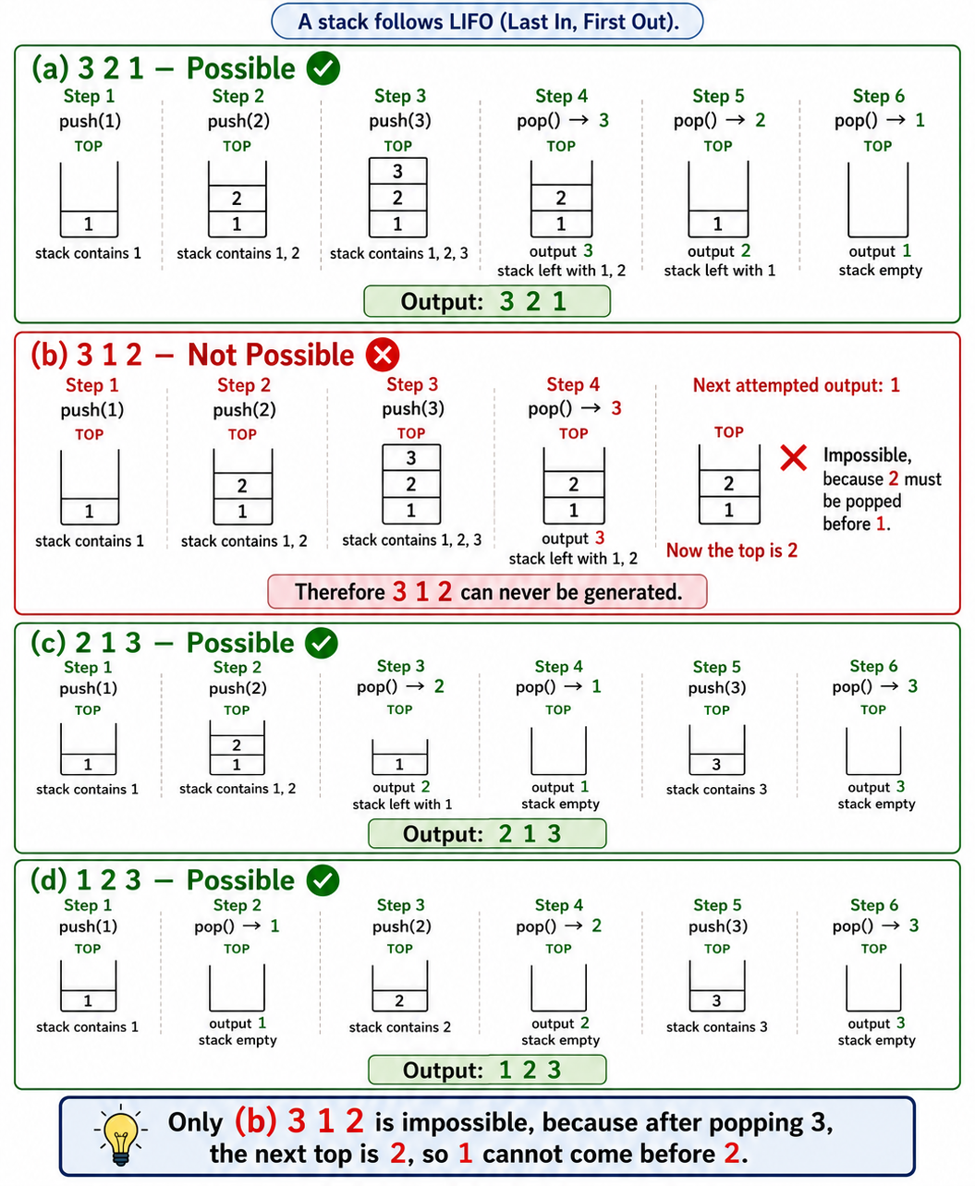
_________________________________________________________________________________________

Q. If the top pointer of the stack pointed to the first inserted element instead of the last inserted one, what would be the time complexity of the stack operations pop and peek in a linked list-based implementation? Explain.

Answer: To perform pop() or peek(), we must traverse the entire linked list to reach the last inserted element which takes O(n) or linear time. Therefore, pop() takes O(n) time and peek() takes O(n) time.
Normally, if the top points to the last inserted element, both pop() and peek() take O(1) time.
_________________________________________________________________________________________
Queue Theory Questions:
Q2A In a linked-list-based queue, what is the time complexity of getting the first inserted element?
Answer: O(1)
Explanation: The head/front of the queue is directly accessible, so fetching the first element takes constant time.

_______________________________________________________________________
Q. What data structures can not be used to reverse a queue? [1 mark]
(a) Array (b) LinkedList (c) Queue (d) Stack

Answer: (c) Queue

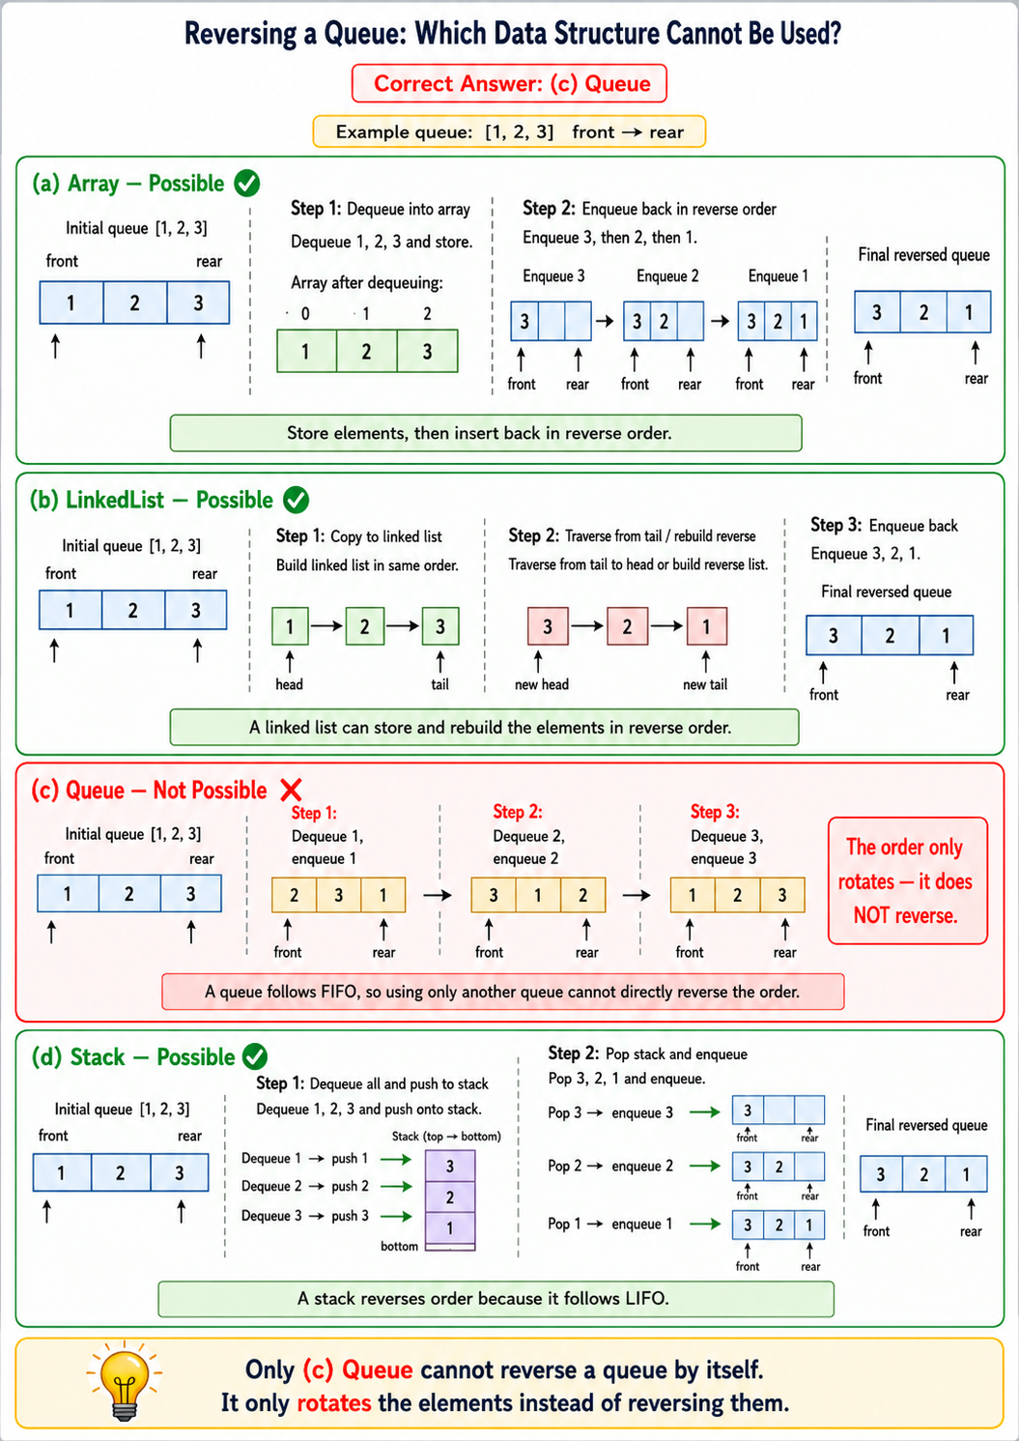
SUMMER2025 QUESTION:--ONLY STACK
Suppose you are developing a personal banking app that tracks daily account activity. Each transaction recorded in the app represents either a deposit (a positive integer) or a withdrawal (a negative integer). These transactions are stored in a Stack, with the most recent transaction on top.
You need to implement a function named depositSum() that takes two arguments:
- a stack of transaction data and
- an integer representing the window size.
The function should compute the sum of only the deposit values within each consecutive window of the given size and return the modified stack containing these summed values.
If the last window contains fewer elements than the specified window size, it should still be processed using the remaining values. The most recent window's sum should appear at the top of the returned stack.
Modified stack means you must return the stack you received via the function parameter.

The Stack class is implemented for you. Its public instance methods are push(), pop(), peek(), and isEmpty(). The isEmpty() method returns a boolean indicating whether the stack is empty. The peek() and pop() methods return null or None if the stack is empty (i.e., underflow condition). All other members of the Stack class are private and should not be accessed directly. You can only use the public instance methods provided. No need to consider the overflow exception for the Stack class. You cannot use any data structure other than the stack. You can create instances of the stack as many times as you want.

Input Stack | Modified Stack | Explanation
stack =  window = 4 | stack = | Since the window size is given as 4, each window will have 4 values (except possibly the last one, if there are fewer remaining elements).  Window 1: has [12, -3, 8, 15]  Sum of deposits: 12 + 8 + 15 = 35  Window 2: has [-7, -20, -6, -2]  Sum of deposits: 0  (Sum is 0 since no deposits in this window)  Window 3: has [9, 14] (remaining 2 elements)  Sum of deposits: 9 + 14 = 23
  Top ➔ | 12
   | -3
   | 8
   | 15
   | -7
   | -20
   | -6
   | -2
   | 9
   | 14
  Top ➔ | 35
   | 0
   | 23

Python | Java
def depositSum(st, window):  # To Do | public static Stack depositSum(Stack st, int window){  // To Do  }

SOlution:
public static Stack depositSum(Stack st, int window) {

Stack result = new Stack();

// Process each window from the top of the stack
while (!st.isEmpty()) {
int depositSum = 0;
int count = 0;

// Process at most 'window' elements
while (count < window && !st.isEmpty()) {
int val = st.pop();

// Add only deposits
if (val > 0) {
depositSum += val;
}

count++;
}

// Store sum of current window
result.push(depositSum);
}

// Put results back into the original stack and reverse the order
while (!result.isEmpty()) {
st.push(result.pop());
}

return st;
}

FALL2025 QUESTION:--ONLY STACK
You are given two stacks, each sorted in non-decreasing (Ascending) order from top to bottom.
Your task is to implement a function named mergeStacks() that merges the two stacks into a single stack and finally returns the merged stack. The merged stack also must be in non-decreasing order.
No need to write the Stack class. Assume, a linked list based stack is already implemented for you. Its public instance methods are push(), pop(), peek(), and isEmpty(). The instance variables of this class are private. You cannot use any data structure other than the stack. You can create as many stacks as you want.
Here, the leftmost value is the top
Given Stacks | Returned Stack | Explanation
stack1 = -2 3 6 6 10  stack2 = 0 4 6 8 | stack = -2 0 3 4 6 6 6 8 10 | Both stack1 and stack2 are in non-decreasing order. They are merged into a stack, and the merged stack is also in non-decreasing order.
stack1 = -5 -2 -1 1 3 6  stack2 = 0 4 8 | stack = -5 -2 -1 0 1 3 4 6 8
stack1 = 0 4 8  stack2 = -5 -2 -1 1 3 6 | stack = -5 -2 -1 0 1 3 4 6 8

Java Stack Creation | Python Stack Creation
Stack stk = new Stack(); | stk = Stack()
Java Method Signature | Python Method Signature
static Stack mergeStacks(Stack stack1, Stack stack2) {  // TODO  } | def mergeStacks(stack1, stack2):  # TODO

SOlution:
// ============================================================
// mergeStacks1
// ============================================================
public static Stack mergeStacks1(Stack stack1, Stack stack2) {
// Step 1: Reverse stack1 into temp1 (largest ends up on top)
Stack temp1 = new Stack();
while (!stack1.isEmpty()) {
temp1.push(stack1.pop());
}

// Step 2: Reverse stack2 into temp2
Stack temp2 = new Stack();
while (!stack2.isEmpty()) {
temp2.push(stack2.pop());
}

// Step 3: Merge into final stack (merged)
Stack merged = new Stack();

while (!temp1.isEmpty() || !temp2.isEmpty()) {
if (temp1.isEmpty()) {
merged.push(temp2.pop());
}
else if (temp2.isEmpty()) {
merged.push(temp1.pop());
}
else {
if (temp1.peek() >= temp2.peek()) {
merged.push(temp1.pop());
} else {
merged.push(temp2.pop());
}
}
}

return merged;
}

// ============================================================
// mergeStacks3
// ============================================================
public static Stack mergeStacks3(Stack stack1, Stack stack2) {
Stack temp = new Stack(); // temporary reversed output
Stack result = new Stack(); // final merged stack

// Merge while both stacks have data
while (!stack1.isEmpty() && !stack2.isEmpty()) {
if (stack1.peek() < stack2.peek()) { // pop ONLY the smaller one
temp.push(stack1.pop());
} else {
temp.push(stack2.pop());
}
}

// Add remaining elements from stack1
while (!stack1.isEmpty()) {
temp.push(stack1.pop());
}

// Add remaining elements from stack2
while (!stack2.isEmpty()) {
temp.push(stack2.pop());
}

// Reverse temp into result to restore top-smallest order
while (!temp.isEmpty()) {
result.push(temp.pop());
}

return result;
}

SPRING2026 QUESTION:--STACK-QUEUE MIXED
At an airport, passengers line up in a queue to board a flight.
- According to the boarding policy, passengers are processed in groups of k.
- Before each group boards, the airline staff reverses the order of passengers within that group for security verification.
- If the last group contains fewer than k passengers, their order remains unchanged.

Write a function/method named queueGroupReverse() that reorganizes the queue according to this rule and returns the updated/modified queue. (Means return the original queue passes in parameter)
Assume that linked-list-based Stack and Queue are already provided. The Stack class provides the public methods push(), pop(), peek(), and isEmpty(), while the Queue class provides the public methods enqueue(), dequeue(), peek(), and isEmpty(). The instance variables of these classes are private.
You cannot use any data structure other than the given Stack and Queue. However, you may create multiple stacks or queues if necessary.
Java Method Signature |  | Python Function Signature
public static Queue queueGroupReverse(Queue q, int k) |  | def queueGroupReverse(q, k):
Sample Given Queue | Sample Returned Queue | Explanation
Queue: 1 2 3 4 5 6 7 8  k = 3  leftmost is the front | (front) 3 2 1 6 5 4 7 8 | Passengers are processed in groups (1 2 3), (4 5 6), and (7 8). The first two groups are reversed, while the last group contains fewer than k passengers and therefore remains unchanged.
Queue: 5 8 11 14 17  k = 4  leftmost is the front | (front) 14 11 8 5 17 | Passengers are processed in groups (5 8 11 14) and (17). The first group is reversed, and the last passenger remains in the same position since the group size is less than k.
Queue: 5 8 11  k = 4  leftmost is the front | (front) 5 8 11

SOlution:
public static Queue queueGroupReverse(Queue q, int k) {

// If queue is empty or k <= 1, no change needed
if (q.isEmpty() || k <= 1) {
return q;
}

// Stack to reverse groups
Stack s = new Stack();

// Queue to store processed elements
Queue result = new Queue();

// Process until original queue becomes empty
while (!q.isEmpty()) {

// Temporary queue for current group
Queue tempQ = new Queue();
int count = 0;

// Take up to k elements from q
while (!q.isEmpty() && count < k) {
int val = q.dequeue(); // remove from q
tempQ.enqueue(val); // store temporarily
count++;
}

// If group size is k → reverse it
if (count == k) {

while (!tempQ.isEmpty()) {
s.push(tempQ.dequeue()); // move to stack
}

while (!s.isEmpty()) {
result.enqueue(s.pop()); // reversed order
}

}

// If group size < k → keep order
else {

while (!tempQ.isEmpty()) {
result.enqueue(tempQ.dequeue());
}
}

}

// Move processed elements back to original queue
while (!result.isEmpty()) {
q.enqueue(result.dequeue());
}

return q;
}

